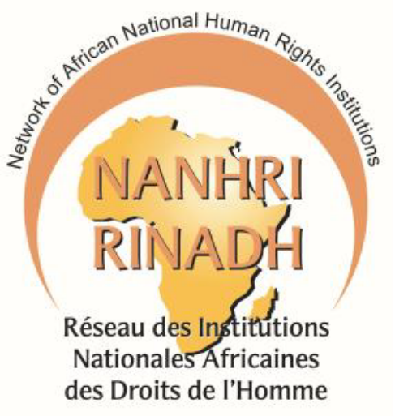

**NETWORK OF AFRICAN NATIONAL HUMAN RIGHTS INSTITUTIONS**

**DURING THE 77th ORDINARY SESSION OF THE AFRICAN COMMISSION ON HUMAN AND PEOPLES’ RIGHTS**

**by Hon. Rtd Judge Mathew P. M. Mwaimu, Chairperson, The Commission for Human Rights and Administrative Governance, Tanzania on behalf of the NANHRI Chairperson Adv. Joseph Whittal.**

**20th October, 2023**

***Your Excellency Samia Suluhu Hassan, President of the United Republic of Tanzania;***

***Your Excellency, The Representative of the Chairperson of the African Union Commission;***

***The Chairperson of the African Commission on Human and Peoples’ Rights Honourable Remy Ngoy Lumbu;***

***Distinguished Representatives of AU Member States;***

***Honourable Members of the African Commission on Human and Peoples’ Rights; Representatives of the African National Human Rights Institutions;***

***Representatives of CSOs, NGOs and other actors; Distinguished Guests;***

***All Protocol observed***

On behalf of the Network of African National Human Rights Institutions (NANHRI), it is with a warm heart that I address you at the 77th Ordinary Session of the African Commission on Human and Peoples’ Rights (the African Commission). We are honoured to address this esteemed August gathering since as African NHRIs we play a dual role of being the bridge between the regional and national human rights systems; as well as being the bridge between Governments and Civil Society Organizations. We are grateful to the Government of the United Republic of Tanzania for hosting and supporting this session. We congratulate the newly appointed Commissioners who will be sworn in during this session.

**Excellencies and Honourable Delegates,**

We are pleased to bring to the attention of the African Commission the outcomes of the deliberations of the Sixth NHRIs forum which took place on 18th-19th October at this same venue under the theme “***The 30th Anniversary of the Paris Principles & The 20th Anniversary of the Maputo Protocol: Amplifying the Role of NHRIs in the Protection of the Rights of Women and other Vulnerable Groups in Africa.”*** On this 30th anniversary of the Paris Principles, African NHRIs have resolved to strengthen their affiliate status relationship with the African Commission by regularly reporting on the situation of human rights in their respective countries and following up on the implementation of the decisions and recommendations of the African Commission.

We also commemorated the 20th anniversary of the Maputo Protocol. Protection of reproductive health rights of women and girls in Africa is essential to human development and the subsequent fulfilment and enjoyment of all other rights. We reiterated Thomas Sankara’s words that ***“The condition of women is therefore at the heart of the question of humanity itself, here, there, and everywhere.”*** We resolved to work together with the African Commission towards achievement of the range of rights protected by Article 14 of the Maputo Protocol including the right to contraception; protection from sexually infectious diseases including HIV/AIDs, and authorization of medical abortion in cases of sexual assault, rape, incest, and where the continued pregnancy endangers the mental and physical health of the mother or the life of the mother or the fetus.

We further resolved to engage with relevant actors to bridge the barriers that continue to hinder the full realization of reproductive health rights. Finally, we undertook to work on a joint campaign with the Special Rapporteur on the Rights of Women in Africa to achieve universal ratification of the Maputo Protocol and the removal of reservations thereto; particularly those placed on Article 14 of the Protocol.

We also took note of the dire status of social protection and social security in the continent. We are concerned that only 17% of the total population in Africa receive at least one social protection benefit as compared to the global average of 47% leaving 1.2 billion Africans without any form of social protection coverage. The situation has been worsened by the aftermath of the Covid-19 pandemic and escalated by climate change induced droughts and floods; and conflict-related displacement among other factors. We welcomed the adoption of the Protocol to the African Charter on Human and Peoples' Rights on the Rights of Citizens to Social Protection and Social Security (The AU Social Security Protocol) by the African Union in 2022. We resolved to work together with the African Commission’s Working Group on Economic, Social, and Cultural Rights to advocate for signature and ratification of the Protocol so that it can enter into force.

**Excellencies and Honourable Delegates,**

We would like to call the attention of the African Commission and Member States to other human rights concerns in our continent. We call for the mainstreaming of human rights in business operations and in the African Continental Free Area Agreement (AfCFTA) which is the theme of our 14th Biennial Conference which is currently ongoing in Accra. We further call for the implementation of the NANHRI declarations and the African Commission resolutions on Business and Human Rights and the AfCFTA agreement.

We are concerned by the unprecedented insecurity in the Sahel region and we continue our call for silencing of the guns. We are utterly disturbed by the ongoing coups and unconstitutional changes of government which have impacted the establishment and functioning of NHRIs. We call upon the African Union to find a lasting solution and work towards strengthening democratic governance. We mourn the recent natural disasters in Morocco and Libya and call for robust early warning and disaster response mechanisms that prioritize the rights of vulnerable groups.

We are alarmed by the shrinking civic space and we urge the African Commission to remind African governments ensure respect and protection of the rights of civil society in line with the African Charter. We call for the unequivocal protection of Human rights Defenders in the continent in accordance with the Marrakech Declaration.

**Finally,**

We commend the positive human rights developments in the continent which are too many to list here. In conclusion, allow me to assure the African Commission and Member States of our commitment towards our common goal of human rights for all in Africa.

I thank you and I wish you all fruitful deliberations.